|  |  |
| --- | --- |
| **Engineering Mathematics and Physics** | **Department** |
| **---------------** | **Division** |
| **2019-2020 Preparatory** | **Academic Year** |
| **Computer** | **Course name** |
| **ECE006** | **Course code** |

**Research project**

**Title:-**

**Build a Simple HTML Website about programming languages**

|  |  |
| --- | --- |
| **Name** | **جنة الله اشرف محمد سعد** |
| **Edu mail** | **ganna195294@feng.bu.edu.eg** |
| **B.N** | **268** |
| **Section** | **12** |
| **Sequence number** | **21** |

**By:**

**Approved by:**

|  |  |
| --- | --- |
| **Examiners committee** | **Signature** |
| **Dr.Ahmed Bayoumi** |  |
| **Dr.Shady Elmashad** |  |
| **Dr.Abdelhamid Attaby** |  |

**GitHup-Link:**

<https://github.com/Ganna-Ashraf/html-project>

**GitHup-Pages (publish website)**

<https://ganna-ashraf.github.io/html-project/>

**Application Brief:**

Computer programming languages allow us to offer instructions in a language that the computer understands to a machine. Much as there are several languages based on humans, there is a variety of computer programming languages that programmers can use to communicate with a computer. The portion of the language a machine can understand is called a "binary." Translating programming language into binary is known as "compiling." Every language, from C Language to Python, has its own distinct features, while programming languages also have commonalities.

Such languages allow computers to process broad and complex swaths of information quickly and efficiently. For instance, if a person receives a list of randomized numbers ranging from one to ten thousand and is asked to position them in ascending order, it is likely to take a substantial amount of time and contain some errors. Today the industry uses hundreds of programming languages. We've collected the 12 most popular, current, and in-demand overviews of the languages below.

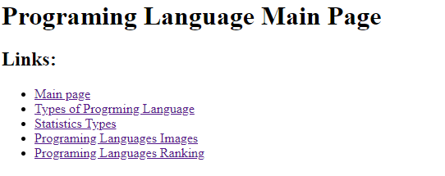**Screens hots**

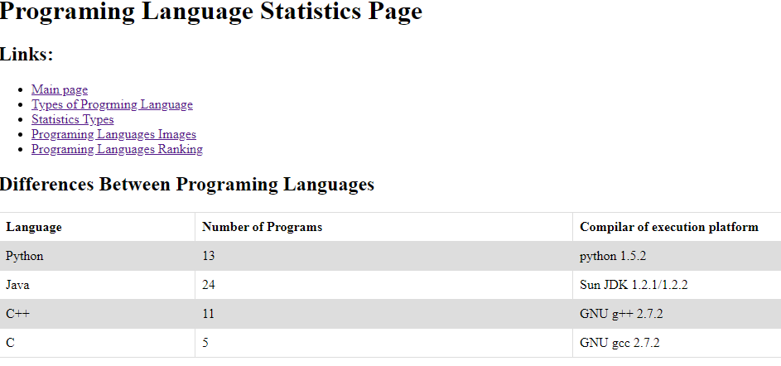

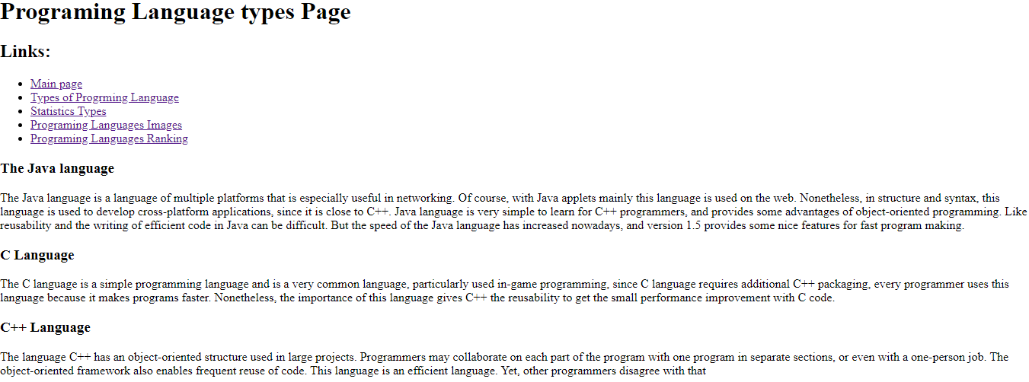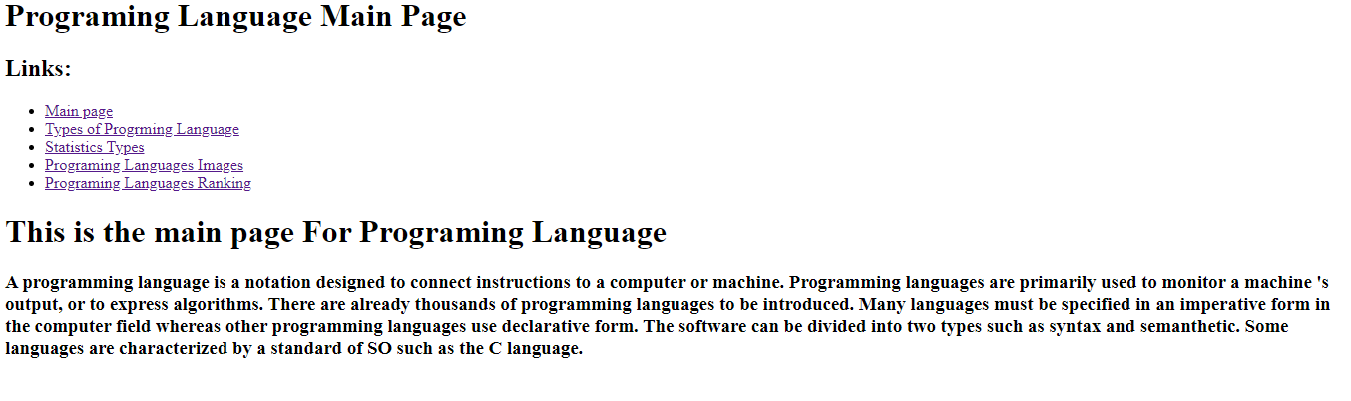

**source code**

